Dr. Discovery

Game Design Document

Game Designer -- Brian Rafferty

CS 583 -- April 24, 2019

Game Overview

**Title:** Dr. Discovery

**Platform:** Mac OS

**Genre:** 2D Side Scroller

**Rating:** (10+) ESRB

**Target:** Casual Gamer

**Release date:** April 24, 2019

**Publisher:** Maximus Games

Dr. Discovery is a 2D Side Scroller where the player is a fabled archeologist who found himself stuck in a land where dinosaurs are somehow alive! The only hope for survival is to make it past his ancient reptilian foes and get behind the wheel of the get-away vehicle. The player must also watch out for holes during their expedition to the vehicle, for they are so incredibly deep that death is certain. On the journey, if the player is feeling brave, they can gain points by jumping on top of the raptors which knocks them off the edge of the cliff faces. If Dr. Discovery survives the trip to the last get-away vehicle, then the user will be rewarded by receiving a high score.

High Concept

Dr. Discovery sets the player in an unknown land where dinosaurs walk the Earth. Evade your foes and jump over obstacles to reach safety and claim victory.

Unique Selling Points

* 100% custom visual assets
* Dynamic gameplay
* Dinosaurs

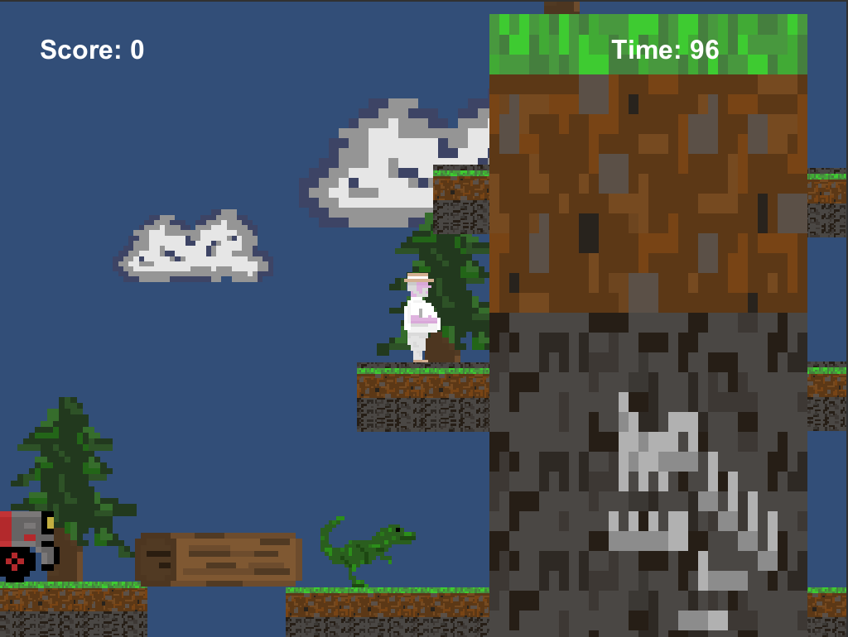

Synopsis

Deserted without any help, you must take the initiative and traverse the dangerous land filled with obstacles and worst of all… dinosaurs!

Game Objectives

Reach the end of each level and jump in the driver seat of the get-away vehicle which will bring you to safety. Getting in the vehicle will yield points, and you can attain even more by jumping on dinosaurs along the way.

Game Rules

Running into a vicious dinosaur or falling into a hole will cause the player to respawn at the beginning of the current level, and all points gained before death will be lost. Jumping on top of dinosaurs will knock them off the cliff faces and yield 100 points to the player. There is a time limit of 120 seconds for each level, and failure to reach the end in the time allotted will result in the player respawning at the beginning of the current level with points reset as before.

Game Structure

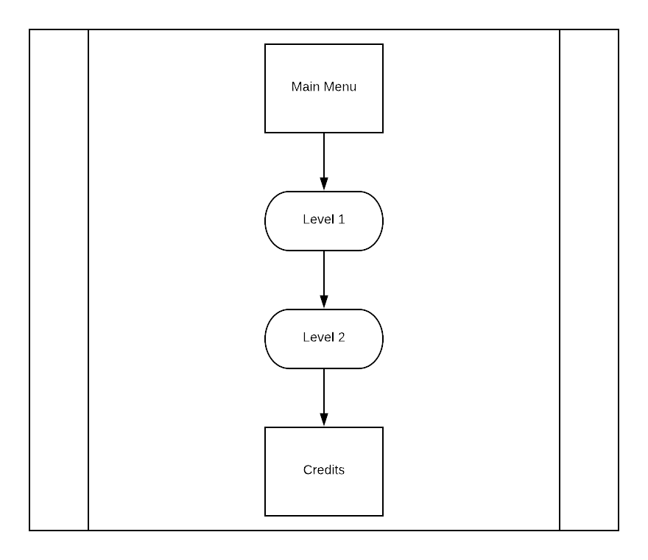

Gameplay

Game Controls

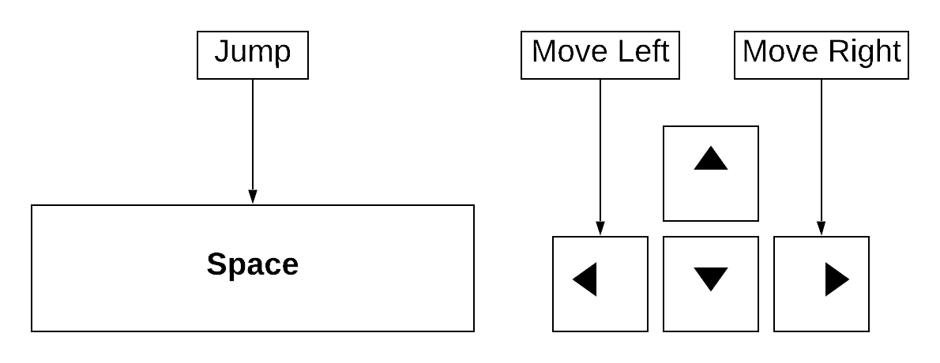

**Note:** Player can double-jump by pressing Space twice in repetition.

Game Camera

The camera is front facing on a 2D plane. There are visual assets placed at varying distances to give the illusion of an expansive environment.



HUD

Located on the top corners of the screen, the HUD includes:

* Player Score
* Time Remaining

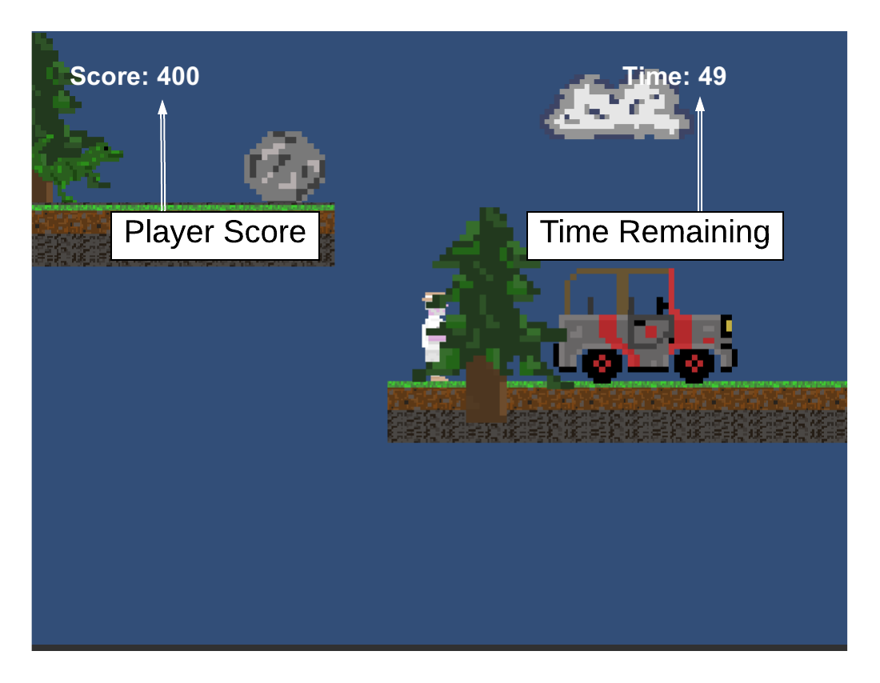

Player

Player Character

The player is a world-renowned archaeologist who found himself in an unknown land where dinosaurs are walking amongst us! He is not built for survival against the harsh elements, and will die from a single bite or falling great distances.

Player Metrics

Speed: 10

Lives: 1

Jump Power: 1100

Attack Damage: N/A

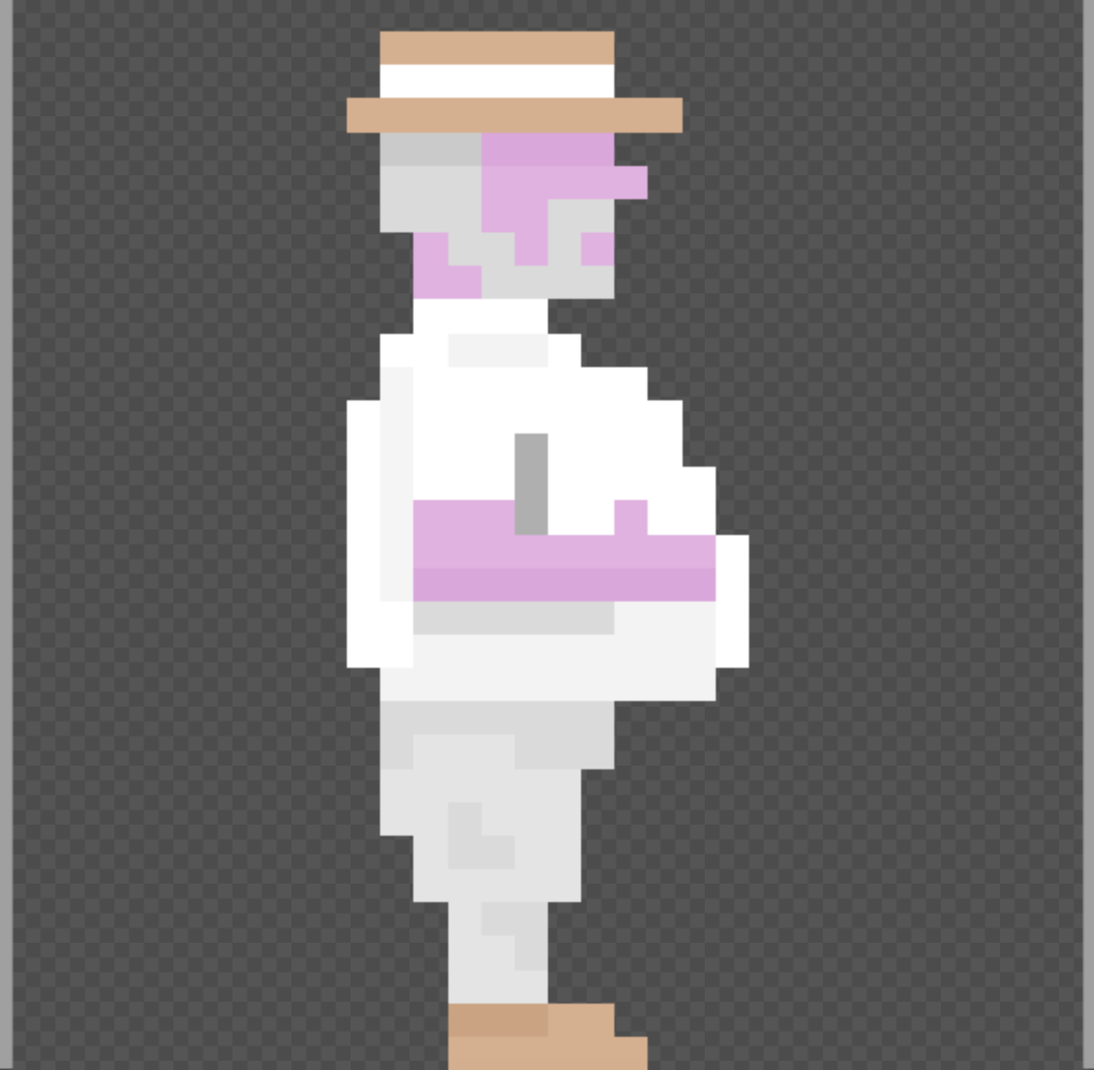

Enemy

NPC Enemies

Dinosaurs dwell in this mysterious land and are lurking throughout the terrain that separates the player from their get-away vehicle. When an enemy gets close enough to bite the player, they cause significant damage and the player must respawn at the beginning of the level.

Raptor

Speed: 3

Lives: 1

Score Value: 100

Attack Damage: Lethal

Attack Distance: 1 ft.

